
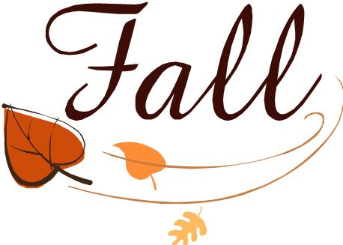

2B Weekly Fridge Sheet
Tuesday, October 13, 2015
Skills We’re Learning:
Spelling: initial, medial, final consonant blends: sl, dr, sk, st, sp-front and end
Reading: Summarize: Sequence of Events (First, Next, Last), Similes, & Rhyme
Story of the week:
A Harbor Seal Pup Grows Up
Homework: Read pages 192-213.

Grammar: Plural Nouns(s, sh, ch, x-es, change y to i + es (cherries) complete change-child-children), Capitalization, and Commas in a letter

Math:

Social Studies:

Vocabulary Words to Know:
examines-looks at carefully

hunger-strong need to eat

mammal-a warm-blooded animal that drinks its mother’s milk and has hair

normal-happening in a regular or healthy way

rescued-saved from danger

young-at an early time of life
Week 7 Spelling Words
(STUDY!!! Test Fri.)

slide slips skin
task still must
crisp spell dress
drop cube fume
what drink stop

Challenge Words
*below
*own
*city
This Week:
Monday: Homework goes home
-Vocabulary Sheet (complete, sign)
-Booklet (pull off, fold, read, sign)
-Read Story: A Harbor Seal Pup
p. 192-213 (Listen, sign book card)

Friday: Spelling & Reading Test
**HOMEWORK DUE**

Important Dates:

Have a Great Week!!
Have a Great Week! ☺Mrs. Rinehart
Sign, Clip, and Return Bottom Slip for a Token!

Student Signature:___________________ Parent Signature:_______________________
Expires 10/16/2015

